Name: _______________________________________________________ Date: _____________________ Core: ______
Arab-Israeli Conflict – Review Packet
Complete all of the questions to help prepare your for the unit test.

*Use the picture to answer
Questions #1-3
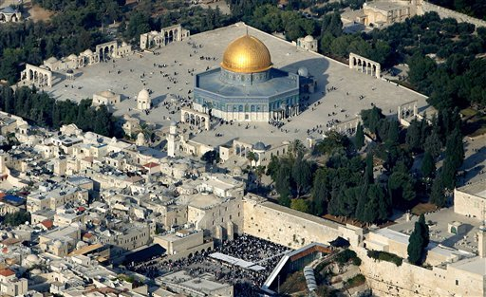

- What city is this?

- What 2 important sites can be seen?

- How does this picture explain the conflict between Palestinians and Israelis?

Define the following terms:
- Refugees
- United Nations
- Occupied Territories
- Dome of the Rock
- Six Day War
- Hamas
- Jerusalem
- Zionism
- Intifada
- Western Wall
Fill in the chart below with the correct information.

 | Official Language | Major Religion | Holy Book | Holiest Site
Palestinians
Israelis

Answer the following questions regarding the film Promises.

- What differences did you notices in the living conditions between the Palestinian and Israeli children?

- How does the Israeli occupation impact the lives of Palestinians, like Faraj and Sanabel?

- Why do you think the film is called Promises?

- Why did Moishe not want to meet the Palestinian children?

- How were sports important in the film?

Examine the map to help you answer questions #19 – 22

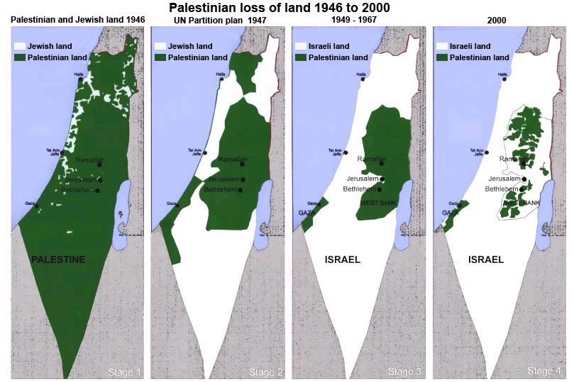

- When did Palestinians lose the largest amount of land?

- Why didn’t the UN Partition Plan of 1947 work?

- Where do most Palestinians live today?

- If you were a Palestinian looking at these maps, how would you feel and why?

How Can We Resolve Conflicts?
Imagine that you have been appointed by the President as the Chief Diplomat for the Middle East. Now is your chance to use your knowledge to bring peace to Israel and Palestine. Write a proposal for how to solve the conflict. Be sure to explain the cause of the problems and how your plan will address these problems. Then use the blank map to create your new borders. Who will control the land? Will there be one country or two? What about Jerusalem? There is no right or wrong solution – just be sure to make a logical, well supported argument!

The cause of the conflict between Israelis and Palestinians is… ______________________________________________ ________________________________________________________________________________________________________________________________________________________________________________________________________________________________________________________________________________________________________________________________________________________________________________________________________
My plan will fix these problems because… _______________________________________________________________
__________________________________________________________________________________________________________________________________________________________________________________________________________________________________________________________________________________________________________________________________________________________________________________________________________________________________________________________________________________________________________
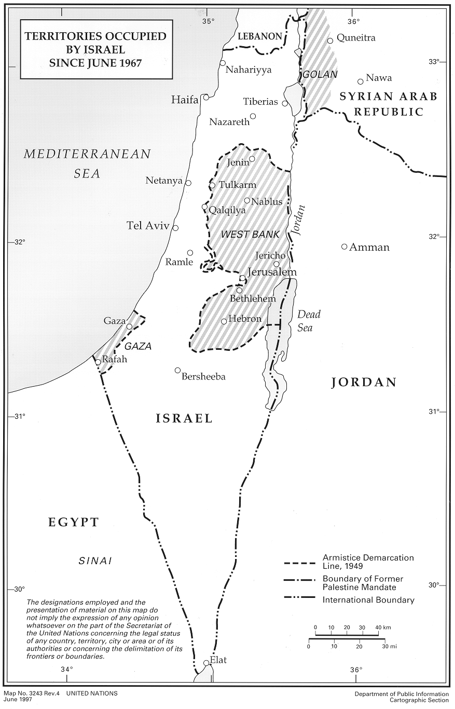
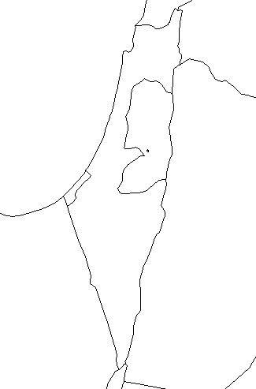
Current Map Your Plan

